CSA1017-SOFTWARE ENGINEERING

CO1 ASSESSMENT TOOL
Title : AI-Based Smart Mining Safety and Equipment Monitoring Platform

NAME : S RUPESH
REG NO : 192571055
DEP : BTECH CS BS

Introduction
Mining is one of the most important industries, providing essential raw materials for construction, manufacturing, energy production, and economic development. Despite its significance, mining remains one of the most hazardous occupations due to risks such as equipment failures, toxic gas emissions, underground collapses, dust exposure, and extreme working conditions. Ensuring worker safety and maintaining reliable equipment are critical challenges for mining companies, as accidents can result in loss of life, operational downtime, financial losses, and environmental damage.
Traditional mining safety systems primarily rely on manual inspections, scheduled maintenance, and periodic monitoring of equipment and environmental conditions. These methods often fail to detect potential hazards in real time, making it difficult to prevent accidents before they occur. In addition, the lack of continuous monitoring and predictive analysis limits the ability of mining organizations to respond quickly to emergencies and optimize operational efficiency.
Recent advancements in Artificial Intelligence (AI), the Internet of Things (IoT), wearable technology, drones, cloud computing, and data analytics have created new opportunities to improve mining safety and productivity. IoT sensors can continuously monitor environmental conditions and equipment performance, while wearable devices track workers' health and location. AI algorithms analyze the collected data to predict equipment failures, identify hazardous situations, and generate timely emergency alerts, enabling proactive decision-making and reducing operational risks.
This case study proposes an AI-Based Smart Mining Safety and Equipment Monitoring Platform that integrates AI, IoT, wearable sensors, drones, and cloud-based analytics into a single intelligent system. The platform continuously monitors mining equipment, environmental conditions, and worker safety, predicts equipment failures using AI, detects hazardous situations in real time, and provides automated emergency alerts through interactive dashboards. By adopting modern software engineering principles and an appropriate Software Development Life Cycle (SDLC) methodology, the proposed solution aims to enhance worker safety, reduce mining accidents, improve equipment reliability, increase operational efficiency, and support sustainable mining operations.

1. Problem Understanding
1.1 Understanding the Problem Statement
Mining is one of the most hazardous industries due to the presence of heavy machinery, underground operations, toxic gases, dust, high temperatures, and unstable geological conditions. Workers are constantly exposed to risks such as equipment malfunction, gas explosions, tunnel collapses, and health emergencies. Traditional mining safety systems mainly depend on manual inspections, periodic equipment maintenance, and human observation, which often fail to detect hazards in real time.
The proposed AI-Based Smart Mining Safety and Equipment Monitoring Platform aims to transform mining safety by integrating Artificial Intelligence (AI), Internet of Things (IoT), wearable sensors, drones, and cloud computing into a unified monitoring system. IoT sensors continuously collect environmental and equipment data, wearable devices monitor workers' health and location, while AI algorithms analyze the collected information to predict equipment failures and detect hazardous conditions before accidents occur. Real-time dashboards and automated emergency alerts enable faster decision-making, reducing accidents and improving operational efficiency.
This intelligent platform shifts mining operations from reactive safety management to proactive and predictive safety management.

1.2 Objectives of the Proposed System
The primary objectives of the proposed platform are:
- Continuously monitor mining equipment using IoT sensors.
- Detect hazardous environmental conditions such as toxic gas leakage, excessive temperature, smoke, and low oxygen levels.
- Predict equipment failures using AI-based predictive maintenance techniques.
- Monitor worker health and location through wearable devices.
- Generate automatic emergency alerts during hazardous situations.
- Analyze operational data to improve mining efficiency.
- Enhance worker safety and reduce workplace accidents.
- Minimize equipment downtime and maintenance costs.
- Support regulatory compliance through digital monitoring and reporting.
- Improve overall productivity and sustainable mining operations.

1.3 Scope of the Problem
The scope of the proposed system includes:
In Scope
- Environmental monitoring
- Equipment condition monitoring
- Worker health monitoring
- Worker location tracking
- Predictive maintenance
- Emergency alert management
- Dashboard and analytics
- Historical data analysis
- Cloud data storage
- Report generation
Out of Scope
- Autonomous mining machinery control
- Financial accounting
- Payroll management
- Mineral extraction planning
- Supply chain management
The system mainly focuses on safety, monitoring, predictive analytics, and operational efficiency.

2. Stakeholder Analysis
2.1 Stakeholders
Stakeholder | Role | Responsibilities | Challenges
Mine Workers | Primary users | Wear safety devices, follow alerts | Exposure to hazardous environments
Safety Officers | Safety monitoring | Monitor risks and emergency response | Delayed hazard detection
Equipment Maintenance Team | Equipment maintenance | Inspect and repair machinery | Unexpected equipment failures
Mine Managers | Operational management | Monitor productivity and safety | Lack of real-time information
Emergency Response Team | Emergency handling | Rescue workers and manage accidents | Delayed incident reporting
Regulatory Authorities | Compliance monitoring | Ensure mining safety standards | Limited access to accurate safety records
System Administrator | System management | Manage users, devices, and database | System maintenance and security
Data Analysts | Data analysis | Analyze operational trends | Handling large amounts of sensor data

2.2 Roles and Responsibilities
Mine Workers
Workers wear IoT-enabled smart helmets and wearable devices that continuously monitor their health status and location. They receive safety alerts during hazardous situations.
Safety Officers
Safety officers monitor environmental conditions through real-time dashboards, verify alerts, coordinate emergency responses, and ensure compliance with safety protocols.
Equipment Maintenance Team
The maintenance team monitors equipment health reports, schedules preventive maintenance, and repairs machinery before failures occur.
Mine Managers
Managers use analytical dashboards to monitor equipment performance, worker safety, operational efficiency, and maintenance schedules.
Emergency Response Team
They receive instant emergency notifications, locate affected workers, and coordinate rescue operations efficiently.
Regulatory Authorities
Authorities review digital safety reports, compliance records, and inspection logs to ensure adherence to mining safety regulations.
System Administrator
Administrators manage users, IoT devices, security settings, cloud databases, and system updates.
Data Analysts
Data analysts evaluate historical mining data to identify trends, optimize operations, and improve AI prediction accuracy.

2.3 Major Challenges Faced by Stakeholders
- Delayed detection of hazardous gas leaks.
- Unexpected equipment breakdowns.
- Lack of continuous worker health monitoring.
- Slow emergency response.
- Human errors during manual inspections.
- Difficulty managing large mining sites.
- Limited predictive maintenance capabilities.
- Poor data integration across departments.

3. Current System Analysis
3.1 Existing System
Most mining companies rely on conventional monitoring methods such as manual inspections, scheduled maintenance, handheld gas detectors, CCTV surveillance, and paper-based safety reports.
Equipment maintenance is generally performed according to fixed schedules instead of actual equipment conditions. Worker health is monitored manually, while emergency response often depends on verbal communication.

3.2 Strengths of the Existing System
- Low initial implementation cost.
- Simple operating procedures.
- Established maintenance practices.
- Familiar to mining personnel.
- Minimal technological infrastructure.

3.3 Limitations of the Existing System
- No continuous equipment monitoring.
- Delayed hazard detection.
- Manual data recording.
- Human errors.
- Lack of predictive maintenance.
- Limited worker tracking.
- Slow emergency communication.
- Poor decision support.
- Inefficient reporting.

3.4 Gap Analysis
Current Problem | Impact | Proposed Improvement
Manual inspections | Delayed hazard detection | Real-time IoT monitoring
Fixed maintenance schedule | Unexpected breakdowns | AI predictive maintenance
Manual worker tracking | Slow rescue operations | GPS-enabled wearables
Paper-based reporting | Inefficient documentation | Cloud-based digital reports
Limited environmental monitoring | Increased accidents | Continuous environmental sensors
Delayed emergency alerts | Higher safety risks | Automated emergency notification

4. Proposed Software Solution
4.1 Proposed System
The proposed solution is an AI-powered cloud-based mining safety platform that integrates IoT sensors, wearable devices, AI analytics, drones, GPS technology, and cloud computing.
The platform continuously collects data from mining equipment, environmental sensors, and wearable devices. AI algorithms analyze this data to predict equipment failures and identify hazardous conditions. Real-time dashboards provide operational insights while automated emergency alerts improve worker safety.
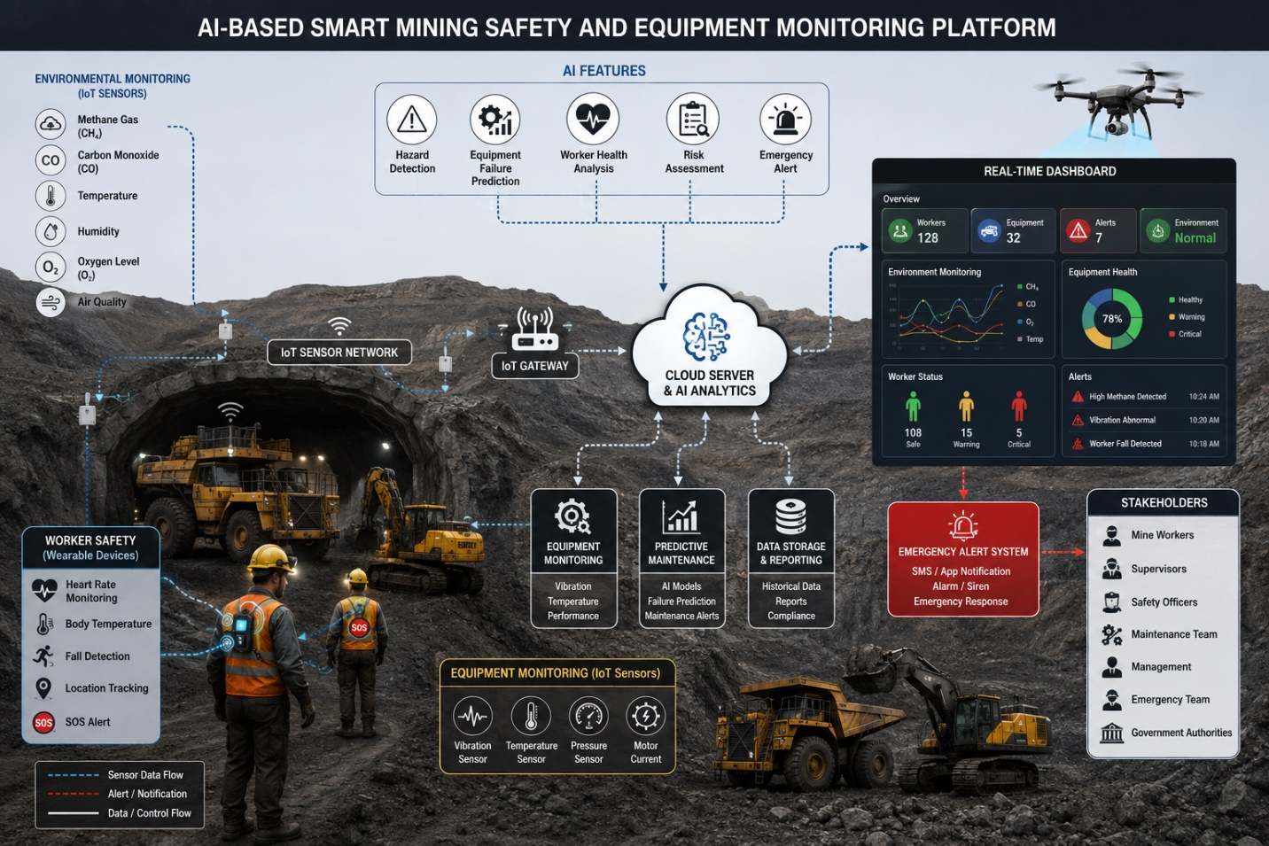

4.2 Major Functional Modules
1. User Authentication Module
- Secure login
- Role-based access control
- User management

2. Equipment Monitoring Module
- Machine health monitoring
- Temperature monitoring
- Vibration monitoring
- Motor performance tracking

3. Environmental Monitoring Module
- Gas detection
- Temperature monitoring
- Humidity monitoring
- Dust monitoring
- Oxygen level monitoring

4. Worker Safety Module
- Heart rate monitoring
- Body temperature monitoring
- Worker location tracking
- Fall detection
- Emergency SOS button

5. AI Prediction Module
- Equipment failure prediction
- Risk prediction
- Hazard analysis
- Predictive maintenance scheduling

6. Emergency Alert Module
- SMS alerts
- Email notifications
- Mobile push notifications
- Siren activation
- Emergency dashboard

7. Analytics Dashboard
- Real-time monitoring
- Equipment status
- Worker safety statistics
- Hazard reports
- Performance analytics

8. Report Management Module
- Daily reports
- Monthly reports
- Incident reports
- Compliance reports

4.3 Functional Requirements
The system shall:
- Register users.
- Authenticate users.
- Monitor mining equipment.
- Monitor environmental conditions.
- Monitor worker health.
- Track worker locations.
- Predict equipment failures.
- Detect hazardous conditions.
- Generate emergency alerts.
- Produce safety reports.
- Store historical data.
- Display analytical dashboards.

4.4 Non-Functional Requirements
Requirement | Description
Performance | Process sensor data in real time with minimal delay.
Scalability | Support additional mines, users, and IoT devices.
Reliability | Operate continuously with high system availability.
Security | Encrypt data, enforce authentication, and apply role-based access control.
Maintainability | Modular architecture for easy updates and maintenance.
Usability | User-friendly dashboards accessible with minimal training.
Availability | Ensure 24/7 operation with backup and disaster recovery mechanisms.
Portability | Accessible through web and mobile applications.
Interoperability | Integrate with various IoT devices and sensors from different manufacturers.

4.5 Application of Software Engineering Principles
Modularity
The platform is divided into independent modules such as equipment monitoring, worker safety, environmental monitoring, analytics, and reporting. Each module can be developed, tested, and maintained independently.
Scalability
Cloud infrastructure allows the system to support multiple mining sites, thousands of sensors, and future feature additions without significant redesign.
Maintainability
The modular architecture, coding standards, and comprehensive documentation simplify maintenance, upgrades, and debugging.
Reliability
Real-time monitoring, automated backups, fault-tolerant design, and continuous system health checks ensure dependable operation.
Usability
An intuitive interface with clear dashboards, visual alerts, and responsive design enables efficient use by workers, safety officers, and managers.
Security
The system uses multi-factor authentication, role-based access control, encrypted data transmission, secure cloud storage, and audit logs to protect sensitive information.

5. SDLC / Framework Justification
Selected SDLC Model: Agile (Scrum)
Why Agile Scrum?
The AI-Based Smart Mining Safety and Equipment Monitoring Platform involves advanced technologies such as AI, IoT, cloud computing, and wearable devices. Requirements may evolve as mining companies identify new safety needs or regulations change. Agile Scrum is therefore well suited because it supports iterative development, continuous stakeholder feedback, and incremental feature delivery.
Justification
- Enables rapid development through short iterations (sprints).
- Allows continuous feedback from mine managers, safety officers, and workers.
- Supports frequent testing and integration of AI and IoT components.
- Facilitates quick adaptation to changing regulatory requirements.
- Encourages collaboration among developers, domain experts, and stakeholders.
- Improves software quality through continuous testing and review.
- Reduces project risks by identifying issues early.
- Supports ongoing maintenance and enhancement after deployment.
How Agile Supports Successful Development
- Sprint planning prioritizes the most critical safety features.
- Daily Scrum meetings improve team coordination.
- Sprint reviews gather stakeholder feedback regularly.
- Continuous integration and testing ensure reliable software.
- Retrospectives enable continuous process improvement.

6. Expected Outcomes and Limitations
6.1 Expected Benefits
The proposed platform is expected to:
- Improve worker safety through continuous monitoring.
- Reduce workplace accidents by detecting hazards early.
- Lower equipment downtime with predictive maintenance.
- Increase equipment reliability and lifespan.
- Improve operational efficiency using real-time analytics.
- Enable faster emergency response through automated alerts.
- Support regulatory compliance with digital reporting.
- Promote sustainable and data-driven mining operations.

6.2 Addressing Identified Challenges
The proposed solution addresses current challenges by:
- Replacing manual inspections with real-time IoT monitoring.
- Predicting equipment failures using AI before breakdowns occur.
- Continuously monitoring worker health and location.
- Providing instant emergency notifications.
- Centralizing operational data for better decision-making.
- Automating compliance reporting and documentation.

6.3 Risks, Implementation Challenges, and Limitations
Risks
- Cybersecurity threats targeting IoT devices and cloud infrastructure.
- Network connectivity issues in underground mines.
- Sensor failures leading to inaccurate readings.
- High initial deployment costs.
Implementation Challenges
- Integration of heterogeneous IoT devices.
- Worker training and adoption.
- Reliable wireless communication in underground environments.
- Calibration and maintenance of sensors.
- Ensuring data privacy and regulatory compliance.
Limitations
- Dependence on stable internet or communication networks.
- AI prediction accuracy depends on the quality and quantity of historical data.
- High maintenance costs for sensors and wearable devices.
- Continuous power supply is required for uninterrupted operation.

6.4 Future Enhancements
Future versions of the platform could include:
- Autonomous inspection drones with AI-powered computer vision.
- Digital twin technology for mine simulation.
- Augmented Reality (AR) support for maintenance personnel.
- Blockchain-based safety audit and compliance records.
- Edge AI for faster on-site decision-making with reduced cloud dependency.
- Integration with autonomous mining vehicles and robotics.
- Advanced predictive analytics using deep learning models.
- Multilingual mobile applications to support diverse workforces.

